Introduction
In previous experiments, we learned how to use a 7-segment display and control LEDs by a button. In this lesson, we will use a 7-segment display and a button together to create a simple digital dice.

Components
- 1 * SunFounder Uno board
- 1 * Breadboard
- 1 * USB cable
- 1 * Button
- 1 * Resistor (10KΩ)
- 8 * Resistor (220Ω)
- 1 * 7-segment display
- 1 * 104 ceramic capacitor
- 1 * 74HC595
- Jumper wires

Principle
The idea behind a digital dice is very simple: a 7-segment display circularly jumps from 1 to 7 rapidly. When the button is pressed, the jumping will slow down until it stops on a number. When the button is pressed again, the process will repeat.
The schematic diagram

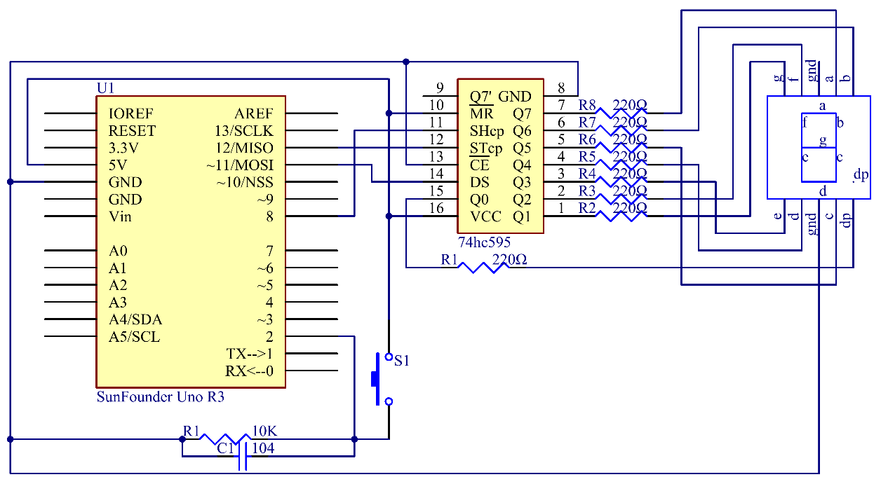

Experimental Procedures
Step 1: Build the circuit

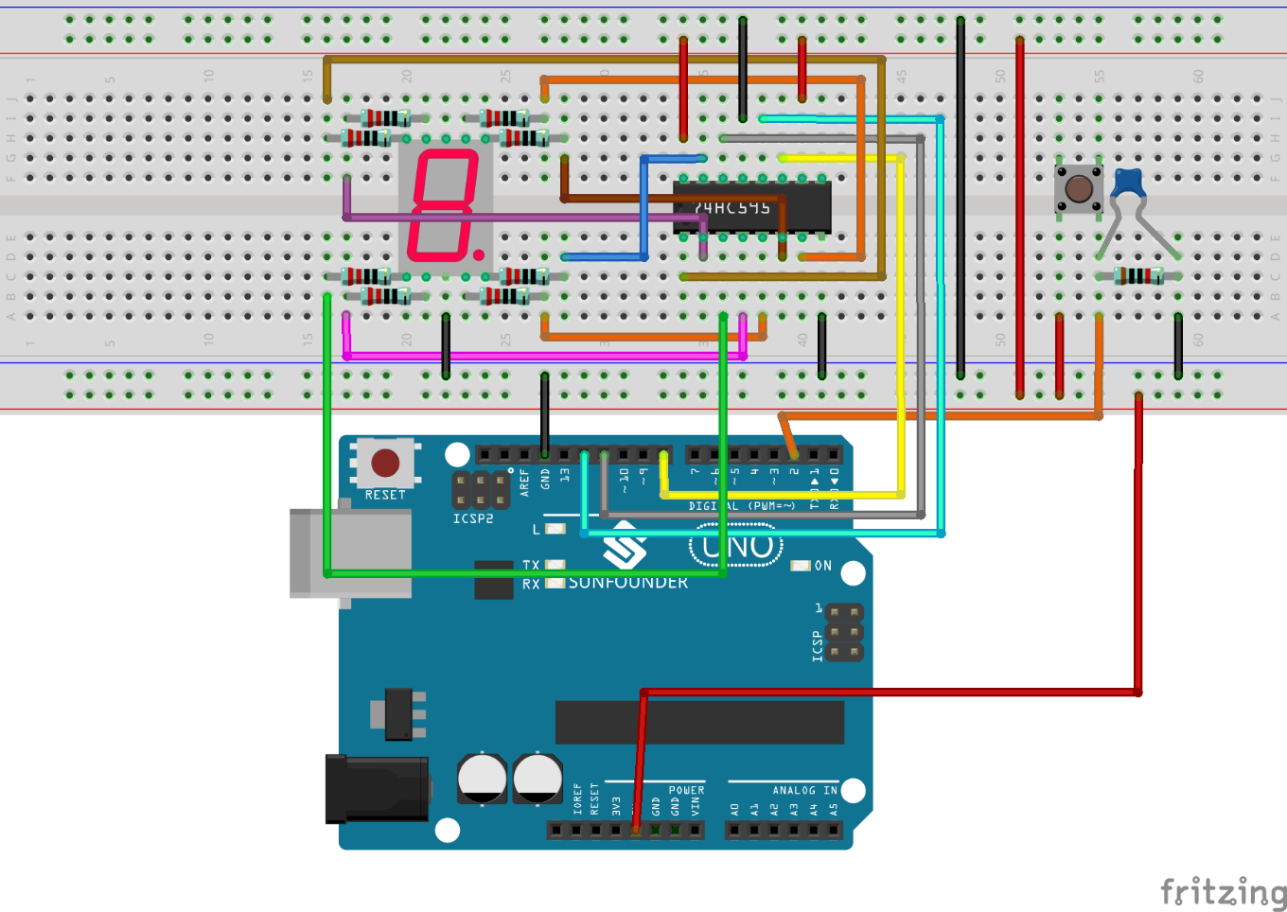

Step 2: Open the code file
Step 3: Select correct Board and Port
Step 4: Upload the sketch to the SunFounder Uno board

You can now see the 7-segment display jump between numbers from 1 to 6. Press the button, and the jumping will slow down until it stops three seconds later. Press the button again, and the process will repeat.

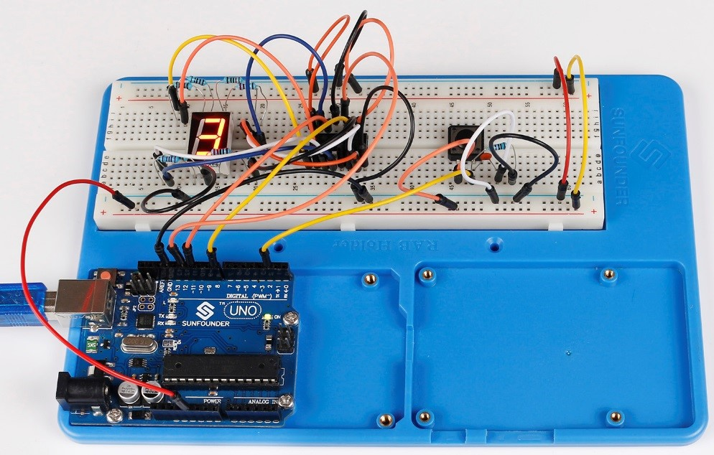

Code
//Digital Dice
/*************************************************
* You can now see the single 7-segment display jump between numbers from 1 to 6.
* When the button is pressed, the jumping will slow down until it stops three seconds later.
* If the button is pressed again, the process will repeat.
*************************************************/
//Email:support@sunfounder.com
//Website:www.sunfounder.com
//2015.5.7
/*********************************************************/
const int latchPin = 12;//Pin connected to ST_CP of 74HC595
const int clockPin = 8;//Pin connected to SH_CP of 74HC595
const int dataPin = 11; //Pin connected to DS of 74HC595
const int ledPin = 13; //ledPin attach to
const int keyIn = 2; //keyIn attach to
int num = 0;

//display 0,1,2,3,4,5,6,7,8,9,A,b,C,d,E,F
int datArray[16] = {
252, 96, 218, 242, 102, 182, 190, 224, 254, 246, 238, 62, 156, 122, 158, 142};

long randNumber;
/***********************************************/
void setup()
{
pinMode(latchPin,OUTPUT); //set the latchPin as an output
pinMode(clockPin,OUTPUT); //set the clockPin as an output
pinMode(dataPin,OUTPUT); //set the dataPin as an output
pinMode(ledPin,OUTPUT); //set the ledPin as an output
pinMode(keyIn,INPUT); //set the keyIn as an input
Serial.begin(9600); // start serial port at 9600 bps:
//initialize the random number generator with a fairly random input A0
randomSeed(analogRead(0));

}
/************************************************/
void loop()
{
int stat = digitalRead(keyIn); //store value read from keyIn
if(stat == HIGH) // check if the pushbutton is pressed
{
num ++;
if(num > 1)
{
num = 0;
}
}

Serial.println(num); // print the num on serial monitor
if(num == 1) //when pushbutton is pressed
{
randNumber = random(1,7); //Generate a random number in 1-7
showNum(randNumber); //show the randNumber on 7-segment
delay(1000); //wait for 1 second
while(!digitalRead(keyIn)); //When not press button,program stop here
int stat = digitalRead(keyIn);
if(stat == HIGH) // check if the pushbutton is pressed
{
num ++;
digitalWrite(ledPin,HIGH); //turn on the led
delay(100);
digitalWrite(ledPin,LOW); //turn off the led
delay(100);
if(num >= 1)
{
num = 0;
}
}
}
//show random numbers at 100 microseconds intervals
// If the button has not been pressed
randNumber = random(1,7);
showNum(randNumber);
delay(100);
}
/************************************************/
//the function to drive 7-segment show numbers
void showNum(int num)
{
digitalWrite(latchPin,LOW); //ground latchPin and hold low for transmitting
shiftOut(dataPin,clockPin,MSBFIRST,datArray[num]);
//return the latch pin high to signal chip that it
//no longer needs to listen for information
digitalWrite(latchPin,HIGH); //pull the latchPin to save the data
}
/************************************************/

